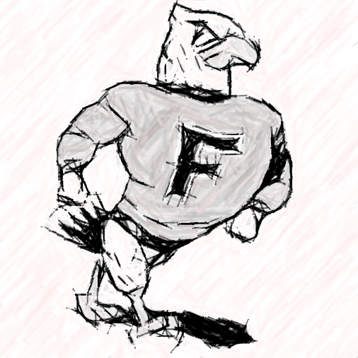

January 2023 Board Highlight

Superintendent’s Summary 

Student Representatives to the Board, Hannah Quint and Leah Lembke were recognized and presented with certificates of appreciation for their service to the board.

Mrs. Duren reported on the Special Education Programs that detailed census reports that are submitted to DESE. Our 5 year trend shows in increase in this program.

Mrs. Huster spoke to the progress monitoring data of the elementary and there was discussion of the scores and the progression of grade levels from year to year.

Mrs. Arnette’s report focused on the end of semester activities for CMS and also highlighted the curriculum work that Ms. Hilgedick is doing to identify additional resources to meet student and instructional needs of the CMS math department.

Mr. Dobson’s report spoke to the incredible performance of Murder at Crimson House which was directed by Mrs. Miner. A special thank you to CMU for the use of The Little Theater for this production. Mrs. Dimond and Ms. Swanson were both highlighted for the learning activities in their classrooms.

Mr. Doolin reported on his attendance at the State Board of Education meeting. Teacher recruitment and retention is still a large concern for the state of Missouri. He also reported on the effectiveness of our Grow Your Own grant program.

The board discussed the food service program and adult lunch prices. The adult prices were not in compliance and will have to be raised. Student prices will more than likely have to be raised at the start of next school year to stay in compliance.

The board revisited the request made to increase the PTO reimbursement rate for unused PTO days. It was approved to move to a tiered system determined by years of service and leaving vs. retirement. The tiers and payment are: Yrs1-5 $15Leaving/$30 Retiring; Yrs. 6-15 $30Leaving/$50 Retiring; and 16+ Yrs. $50 Leaving/$70 Retiring.

The board took the following actions:

1. Approved the purchase of a convection oven for the kitchen. This was paid for by a grant Paula received.
2. Approved the increase of PTO reimbursement to a tiered system based on years of experience and leaving vs retiring from the district.
3. Approved the purchase of an ice machine for the high school.

There was lengthy discussion in regards to adding wrestling as an extra-curricular activity. However, no action was taken.

Closed Session Discussion included approval of a substitute teachers, approval of assistant track coaching position, a coaching resignation and the superintendent evaluation.

**Next BOE Meeting:**

*February 15, 2023 Board Meeting*

**Board Members:**

*Aaron Bentley*

*Kristen Gibbs*

*Matt Hudson*

*John Stroupe*

*Skip Vandelicht*

*Sarah Wies*

*Shauna Young*

**Public Participation at Board Meetings**

Everyone is invited and encouraged to attend school board meetings. See Board Policy BDDH for information on participating at Board meetings regarding grievances, written correspondence, agenda items, and public hearings.